D. Ehab's Last Corollary
time limit per test
1 second
memory limit per test
256 megabytes
input
standard input
output
standard output
Given a connected undirected graph with nn vertices and an integer kk, you have to either:
- either find an independent set that has exactly ⌈k2⌉⌈k2⌉ vertices.
- or find a simple cycle of length at most kk.
An independent set is a set of vertices such that no two of them are connected by an edge. A simple cycle is a cycle that doesn't contain any vertex twice.
I have a proof that for any input you can always solve at least one of these problems, but it's left as an exercise for the reader.
Input
The first line contains three integers nn, mm, and kk (3≤k≤n≤1053≤k≤n≤105, n−1≤m≤2⋅105n−1≤m≤2⋅105) — the number of vertices and edges in the graph, and the parameter kk from the statement.
Each of the next mm lines contains two integers uu and vv (1≤u,v≤n1≤u,v≤n) that mean there's an edge between vertices uu and vv. It's guaranteed that the graph is connected and doesn't contain any self-loops or multiple edges.
Output
If you choose to solve the first problem, then on the first line print 11, followed by a line containing ⌈k2⌉⌈k2⌉ distinct integers not exceeding nn, the vertices in the desired independent set.
If you, however, choose to solve the second problem, then on the first line print 22, followed by a line containing one integer, cc, representing the length of the found cycle, followed by a line containing cc distinct integers not exceeding nn, the vertices in the desired cycle, in the order they appear in the cycle.
Examples
input
Copy
4 4 3
1 2
2 3
3 4
4 1
output
Copy
1
1 3
input
Copy
4 5 3
1 2
2 3
3 4
4 1
2 4
output
Copy
2
3
2 3 4
input
Copy
4 6 3
1 2
2 3
3 4
4 1
1 3
2 4
output
Copy
2
3
1 2 3
input
Copy
5 4 5
1 2
1 3
2 4
2 5
output
Copy
1
1 4 5
Note
In the first sample:
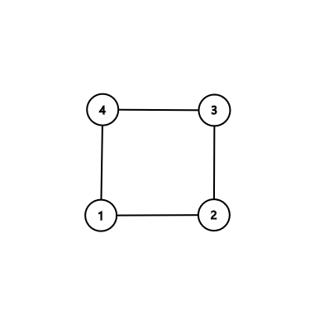
Notice that printing the independent set {2,4}{2,4} is also OK, but printing the cycle 1−2−3−41−2−3−4 isn't, because its length must be at most 33.
In the second sample:
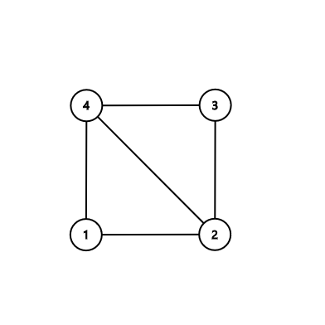
Notice that printing the independent set {1,3}{1,3} or printing the cycle 2−1−42−1−4 is also OK.
In the third sample:
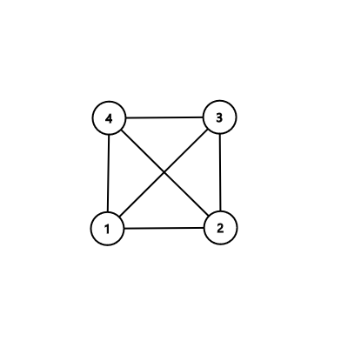
In the fourth sample:
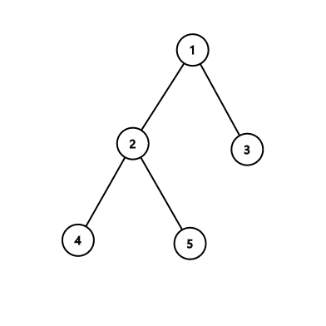
#include<iostream>
#include<cstdio>
#include<cstring>
#include<algorithm>
#include<map>
#include<vector>
#include<set>
#define ll long long
using namespace std;
const int maxn=2e5+10;
vector<int> G[maxn];
vector<int> color[2];
vector<int> cyc;
int pre[maxn];
int dep[maxn];
int vis[maxn];
int n,m,k;
void dfs1(int x,int f,int c)
{
color[c].push_back(x);
for(auto to:G[x])
{
if(to!=f)
{
dfs1(to,x,!c);
}
}
}
void dfs2(int x,int cnt)
{
dep[x]=cnt;
for(auto to:G[x])
{ if(to==pre[x]) continue;
if(!vis[to])
{
pre[to]=x;vis[to]=1; dfs2(to,cnt+1);
}
else
{
if(dep[to]<dep[x])
{
int dd=dep[x]-dep[to]+1;
if(dd<=k)
{ int node=x;
while(1)
{
cyc.push_back(node);
if(node==to) break;
node=pre[node];
}
cout<<2<<endl;
cout<<cyc.size()<<endl;
for(auto it:cyc) cout<<it<<" ";
exit(0);
}
}
}
}
}
int main()
{
scanf("%d %d %d",&n,&m,&k);
for(int i=1;i<=m;i++)
{
int u,v;
scanf("%d %d",&u,&v);
G[u].push_back(v);
G[v].push_back(u);
}
if(m==n-1)
{ //cout<<"hehe"<<endl;
dfs1(1,1,0);
int c;
if(color[0].size()>color[1].size()) c=0; else c=1;
cout<<1<<endl; int i=1;
for(auto it:color[c]) {if(i>(k+1)/2) break;cout<<it<<" ";i++;}
}
else
{
pre[1]=1;
dfs2(1,1);
for(int i=1;i<=n;i++)
{
if(dep[i]==k)//既然深度大于k的话肯定有个点深度是k
{
int node=i;
while(1)
{
cyc.push_back(node);
if(node==1) break;
node=pre[node];
}
cout<<1<<endl;int ct=1;
for(int j=0;j<cyc.size();j+=2) {if(ct>(k+1)/2) break;cout<<cyc[j]<<" ";ct++;}
break;
}
}
}
return 0;
}

